# **COAL LAB MID 1:**

QUESTION 1 A:

INCLUDE Irvine32.inc

.data

w DWORD 1h

x DWORD 2h

y DWORD 3h

z DWORD 4h

.code

main PROC

mov ebx , w

mov ecx , x

add ebx , ecx

mov ecx , y

mov edx , z

sub ecx, edx

sub ebx, ecx

mov eax, ebx

call dumpregs

exit

main ENDP

END main

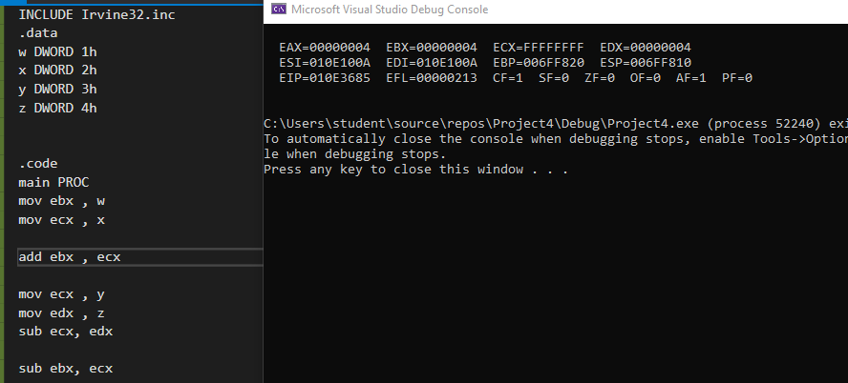

QUESTION 1 B:

INCLUDE Irvine32.inc

.data

count DWORD ?

sum DWORD ?

avg DWORD ?

.code

main PROC

mov ecx , 12

mov eax, 0h

mov count,0h

mov sum, 0h

mov avg,0h

l1:

add count, 1

CALL READHEX

CALL WRITEHEX

add sum, eax

call dumpregs

loop l1

mov eax,sum

CALL WRITEDEC;SUM

mov eax,count

mov ebx,sum

div ebx

mov eax, ebx

CALL WRITEDEC;AVG

mov eax,count

CALL WRITEDEC;count

exit

main ENDP

END main

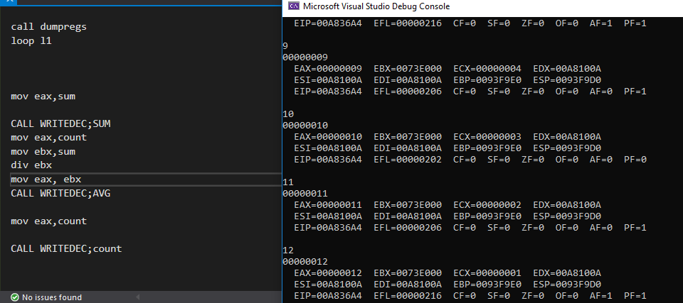

QUESTION 2 A:

INCLUDE Irvine32.inc

.data

arr DWORD 10h,20h,30h,40h

.code

main PROC

mov esi, OFFSET arr

mov eax,[esi]

mov ebx,[esi+4]

mov ecx, [esi+8]

mov edx, [esi+12]

call dumpregs

xchg eax, edx

xchg ebx,ecx

call dumpregs

exit

main ENDP

END main

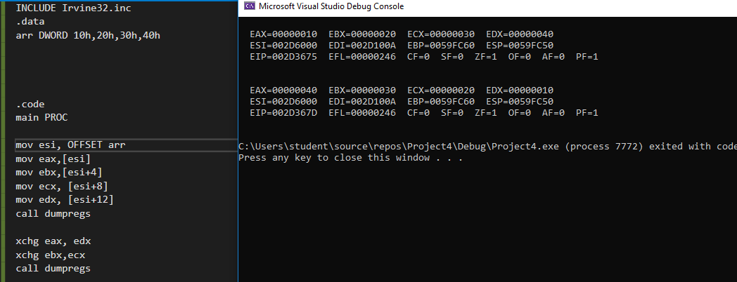

QUESTION 2 B:

INCLUDE Irvine32.inc

.data

val1 BYTE 79h

val2 WORD 100h

val3 DWORD ?

.code

main PROC

movzx eax,val1

movzx ebx, val2

imul ebx

mov val3, eax

mov eax, val3

CALL WRITEHEX

call dumpregs

exit

main ENDP

END main

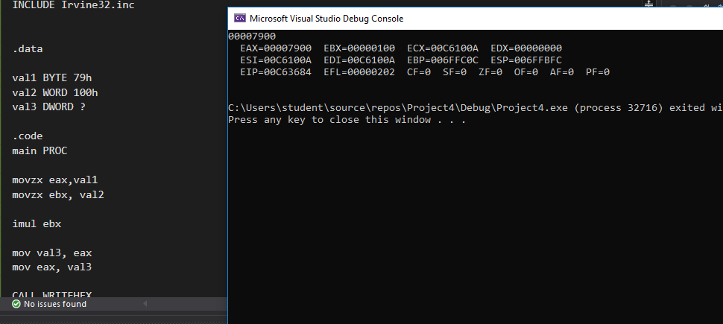

QUESTION 3 A:

INCLUDE Irvine32.inc

.data

ARR DWORD 2,0,75,45,1,6,1,0

.code

main PROC

mov esi , OFFSET ARR

mov ecx,8

l1:

add eax,[esi]

add esi,4

loop l1

CALL WRITEDEC

call dumpregs

exit

main ENDP

END main

